The objective of this assignment is to assess your understanding of functional dependencies and normalization.

**Academic Integrity Statement:**This assignment must be completed independently. By submitting this assignment, I state that have completed this assignment independently. Type your name in the box below to affirm the above statement.

**NAME:** Anthony Popovich

**Part 1: Functional Dependencies** (40%)

* **NOTES:** Underlined attributes are either the primary key or part of the primary key. For example, R(A, B, C) indicates that A,B is a composite primary key.
* Use the same notation as in the text.
* For example, to take the following relation: R(X, Y, Z) with FD: (X,Y) → Z and (X,Z) → Y from 3NF to BCNF, you would recommend the following: R(X, Z) and R2(Z, Y), as described in the text on page 172-173 using the STUDENT_ADVISOR relation.
* In relational notation, relation names are capitalized, the primary key is underlined and foreign keys are italicized. Here’s an example: R1(A, *B*, C) and R2(B, D, E, F) . B is a PK in R2 and an FK in R1.

1. Given relation R(A, B, C, D) with the following functional dependencies (FD): (A, B) → C and A → D
   1. What is the lowest normal form this relation violates? (Lowest normal form is 1st, followed by 2nd, followed by 3rd, followed by Boyce-Codd Normal Form. If a relation has a partial dependency, then it satisfies 1st normal form but violates 2nd normal form.)

**I believe that the given relation R(A, B, C, D) with the functional dependencies (FD): (A, B)** →  **C and A** → **goes against the Boyce-Codd Normal Form (BCNF).**

* 1. Using the relational notation format above, modify the relation so that it is in Boyce-Codd Normal Form (BCNF). (Consider adding tables, moving attributes between tables, etc. Be sure to underline primary keys and italicize foreign keys.)

**If you bring the relation into BCNF we have to make sure that for every non-trivial functional dependency X → Y and X must be super key. Every determinant (X) of a non-trivial dependency must be a super key.**

1. Relation R(A, B, C, D, E) has the following functional dependencies:
   * (A,B) → C
   * (A,B) → D
   * D → E
   1. What is the lowest normal form that this relation violates?

**The lowest normal form that this relation can violate is 2NF this is because the functional dependency D** → **E creates a partial dependency.**

* 1. Using the relational notation format above, modify the relation so that it is in Boyce-Codd Normal Form (BCNF).

**Relation 1 is R1 (D,E) with a functional dependency D → E.**

**Relation 2 is R2 (A,B,C,D) with a functional dependency (A, B) → C and (A, B) → D**

1. Identify the functional dependency rule for each of the following items:
   1. If A → B and B → C, then A → C. What is the name for this type of functional dependency? **Transitivity**
   2. If C → (D, E), then C → D and C → E. What functional dependency rule does this demonstrate? **Decomposition**
   3. If C → D and C → E, then C → (D,E). What functional dependency rule does this demonstrate? **Augmentation**
2. Identify at least 3 functional dependencies in the table below. (For the purpose of this exercise, you can assume this is the complete universe of data for these attributes.)

|  |  |  |  |  |
| --- | --- | --- | --- | --- |
| StuID | StuName | Grade | Major | Course |
| 101 | Tyshawn | 88 | CSC | Intro to Comp |
| 102 | Keshia | 82 | Acctg | Intro to Comp |
| 103 | Tyshawn | 88 | CSC | Database |
| 104 | Keshia | 91 | Acctg | Sys Des |
| 105 | Maria | 95 | MIS | Sys Des |
| 106 | Sri | 95 | PSCI | Arts Crafts |

**Functional Dependencies:**

**StuID → StuName**

**StuName → Major**

**Major→ StuName**

**Part 2: Normalization** (60%)

**Convert the form below into a list of tables, attributes, primary and foreign keys in the standard form of documentation. For example, MERCHANDISE(MerchNumber, MerchDescription, *CustomerNumber*, etc… where the name of the table is in capital letters, primary keys are underlined, and foreign keys are italicized. The tables should be in Boyce Codd Normal Form (BCNF).**

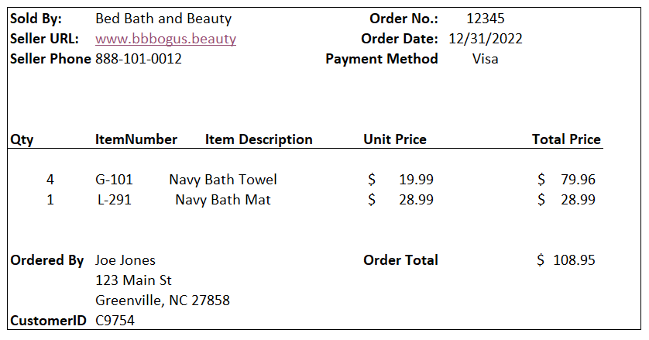

**List your relations below:**

**Final Relations in BCNF Notation:**

SELLER (**SellerID***,* SellerName, SellerURL, SellerPhone)

CUSTOMER (**CustomerID**, CustomerName, CustomerAddress)

ORDER (**OrderNo**, OrderDate, PaymentMethod, OrderTotal, SellerID*,*CustomerID)

PRODUCT (**ItemNumber**, ItemDescription, UnitPrice)

ORDER_ITEM (**OrderNo**, **ItemNumber**, Quantity, TotalPrice)